|  |  |
| --- | --- |
| Course Name | ITD 2313 – Script Programming |
| Instructor | Put instruction name here |
| Student Name | Put student name here |
| Due date | Put assignment due date here |
| Grade | Put grade earned here |
| Grading Comments | Put instructor comments here |

# Selection if and if-else statements

## The boolean type, Comparisons, and Boolean expressions

### Page 78

1. At the top of the page, you will find a code example block with several boolean expressions to enter

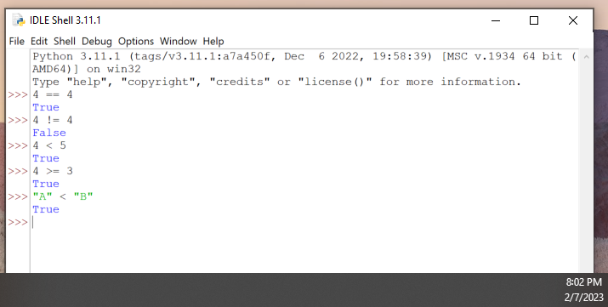

1. About 3/4 the way down on the page, you will find a code example block starting with import math.  This is the final code example block on the page.

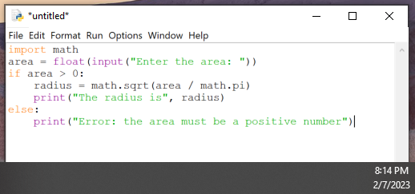

1. You do not type in the if template as part of this exercise.

## if-else statements

### Page79

1. At the half way point is your first code example block for this page

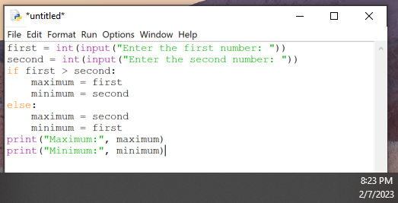

1. The second and final for the page hits at about the 2/3 mark on the page and covers min/max functionality.

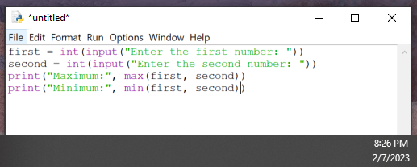

## Multi-way if statements

### Page 81

1. The first of the 2 code example blocks is near the top of the page.

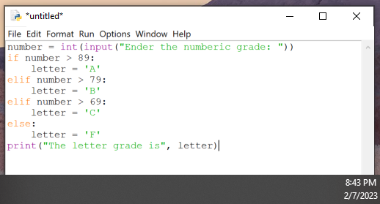

1. The second code example block is in the middle of the page.

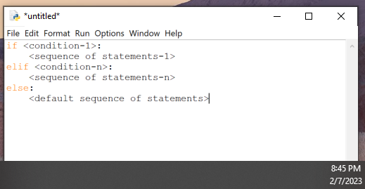

## Logical Operators and Compound boolean expressions

### Page 82

1. The code example block is about 1/4 the way down on the page.

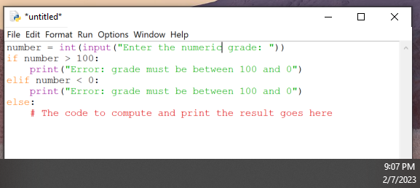

1. The second code example block is about 1/2 way down.  Notice in this example that there is a single line comment saying that the compute and print code goes here.  I would like you to replace that comment with the code the computers the Square of the number they input and prints out the result to the user.

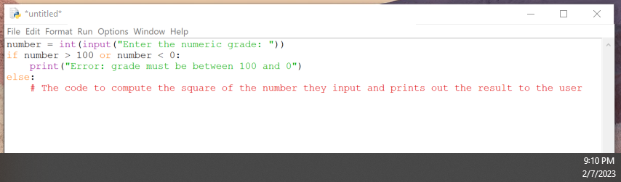

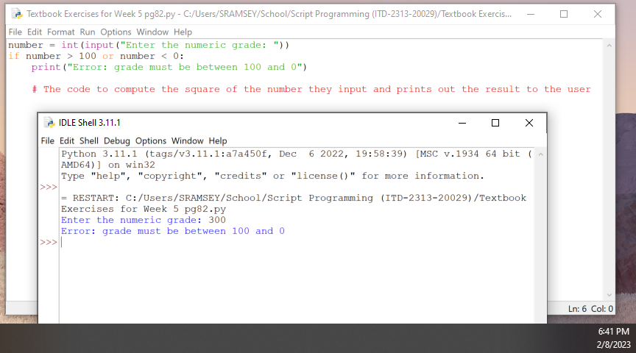

1. The third code example block is about 2/3 the way down the page.  It also has a single line comment that will need to be replaced with code the computes and displays the square of the number input.

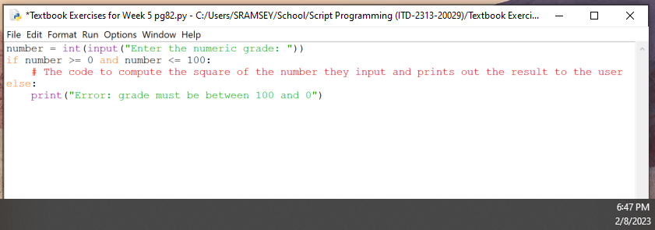

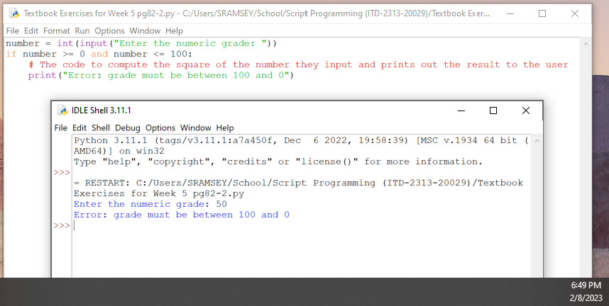

1. Steps 2 and 3 show code but not any results in the text.  You will need to execute the code so that it shows the results on both sides of the if statement.  This will mean 2 screen shots for each step.  One shows the true and one shows the false.

### Page 83

1. The first code example block on the page is at the 1/2 way point on the page.

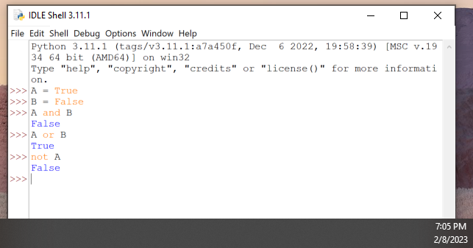

1. The 2nd and final code example block is on the bottom of the page.  It does not spill onto the next page

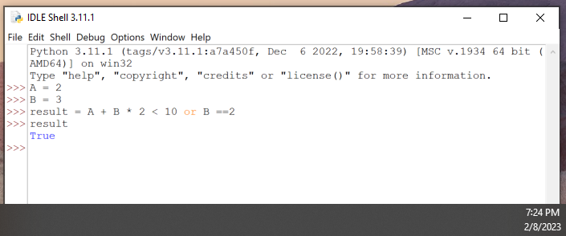

## Short Circuit evalution

### Page 84

1. The first code example block is about 2/3 the way down the page.  Show how it runs with a couple of different values.  Count needs to be set to 0 at least 1 time.

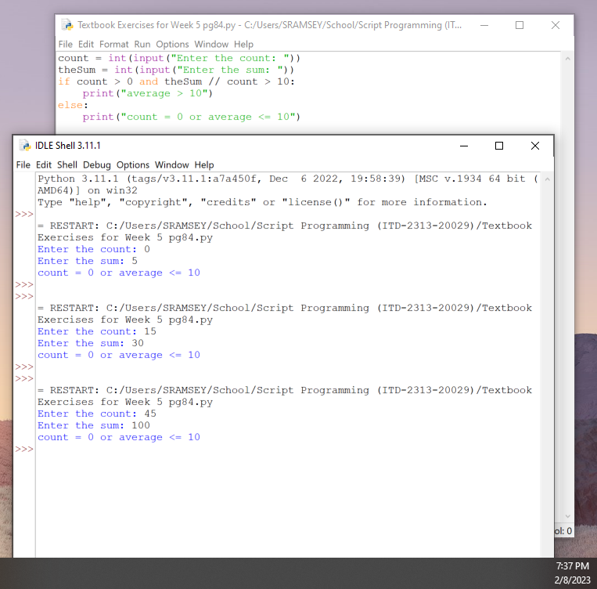

1. For a better understanding of the topic, consider for your own learning to switch the order of the two items in the compound boolean expression.  That means, check the count>0 on the Right Side of the AND.  See what happens when you run it with Count = 0.  This is just for you to further understand and see the results.  You will not need to screen shot this step.

# Conditional Iteration:  The while Loop

## The structure and behavior of a while loop

### Page 87

1. At the half way point on the page is the only code example block on the page.  When you execute it, be sure to use the same numbers shown in the text to get the same answer as in the text.

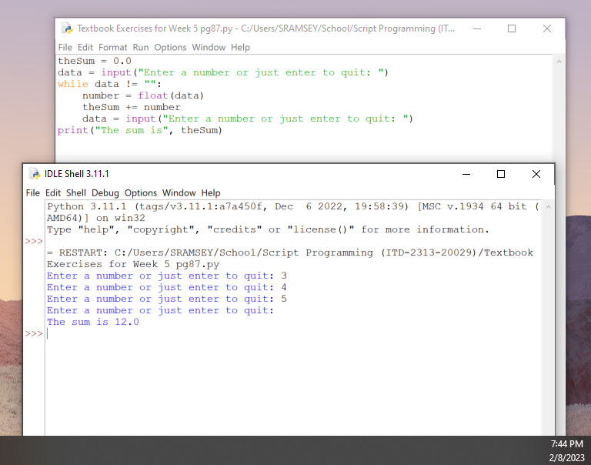

## Count control with a while loop

### Page 88

1. At the top of the page, there are two while loop code examples in that block.  The issue is that they do not show you the results.  Be sure you capture the results.

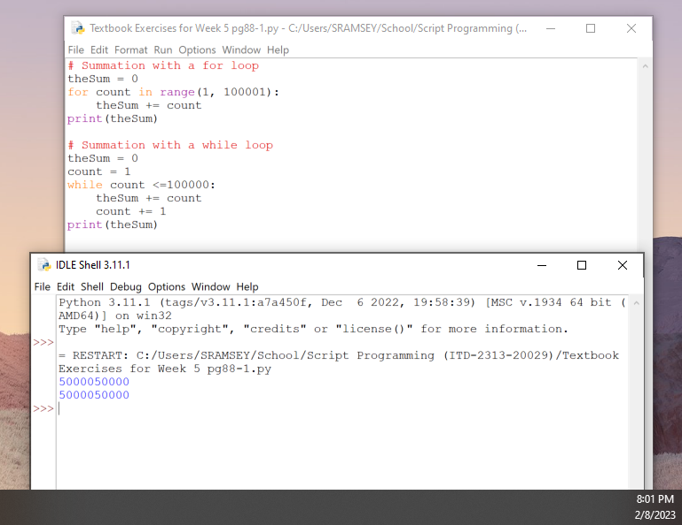

1. About the 2/3 mark on the page, they do it again and show you two loops without showing the output.  Enter both the loops in the code example block and catch the output for them.

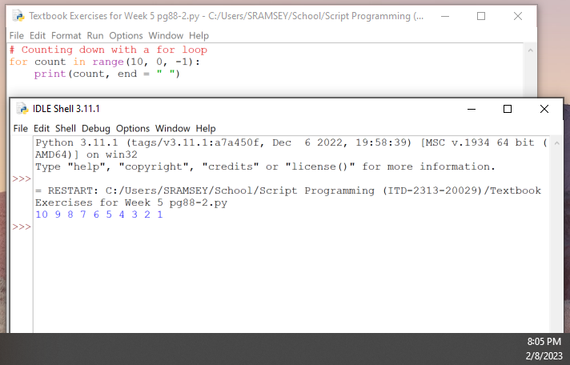

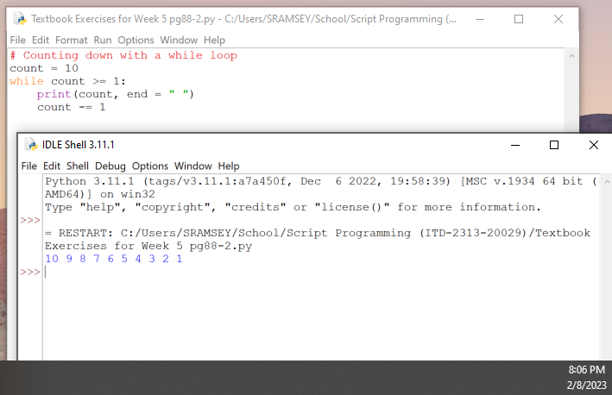

## The while true loop and the break statement

### Page 89

1. The first of the code example blocks is at the top of the page.  They do now show you the results but you will need to catch some portion of the results in a screen shot

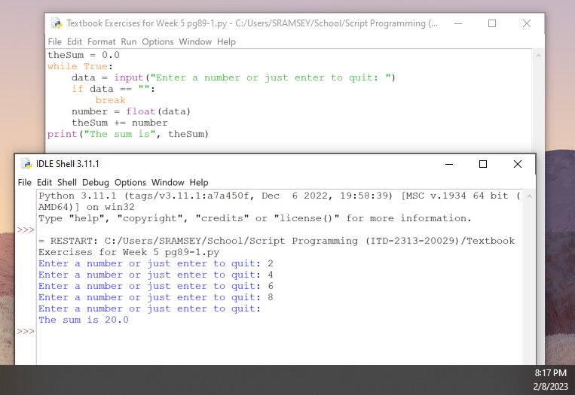

1. The second code example is 1/2 down the page.  A sample run is show so duplicate that sample run when you do the screen shot

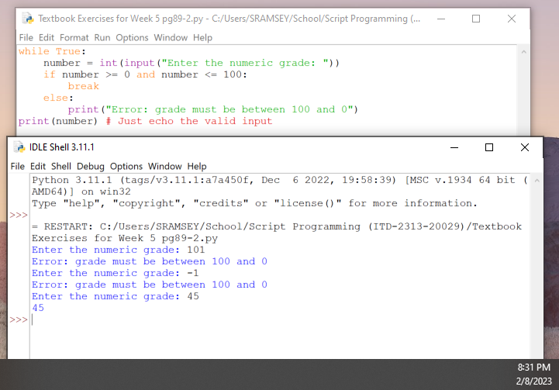

1. At the very bottom is the last of the three code example blocks for this page.  It does not spill onto the next page.  Be sure to grab some output i your screen shot.

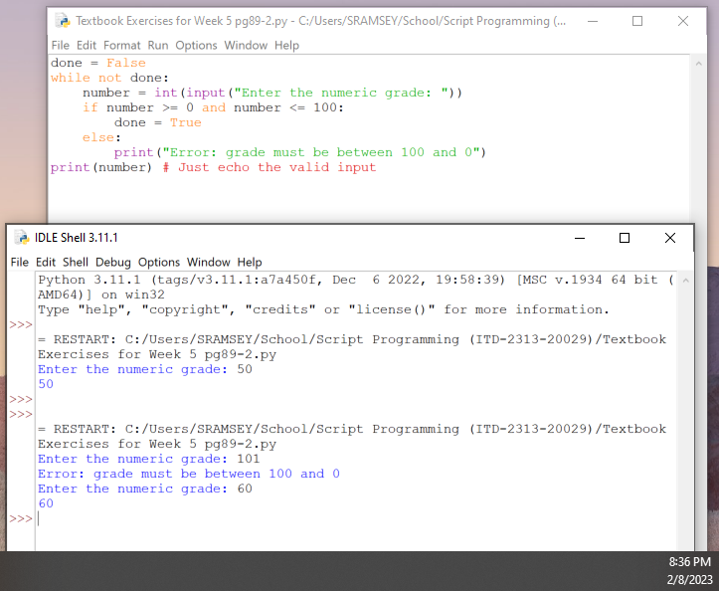

## Random Numbers

### Page 90

1. Ever wanted to make you own dice roller?  Well here you go, using this code example block in the middle of the page will let you make one.  Your output most likely will different since the rolls are supposed to be random.

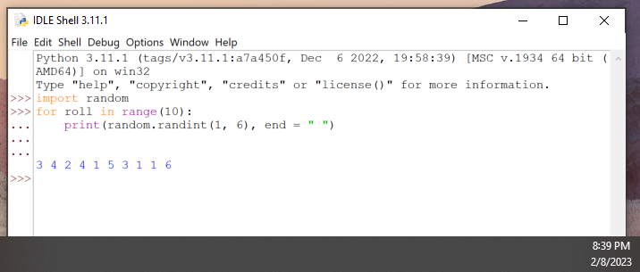

1. Another code block begins about 3/4 the way down but it spills onto the next page so it will be part of the page 91 screen shots.

### Page 91

1. The code started at the end of page 90 is finished up at the top of page 91.  Your output may vary again since there is a random number involved.  Guess the best way you can.

